Flow Diagram & User Stories

Date | 17 February 2026
Team ID | LTVIP2026TMIDS88973
Project Name | Civil Engineering Insight Studio
Maximum Marks | 4 Marks

Data Flow Diagrams:
A Data Flow Diagram (DFD) is a traditional visual representation of the information flows within a system. A neat and clear DFD can depict the right amount of the system requirement graphically. It shows how data enters and leaves the system, what changes the information, and where data is stored.

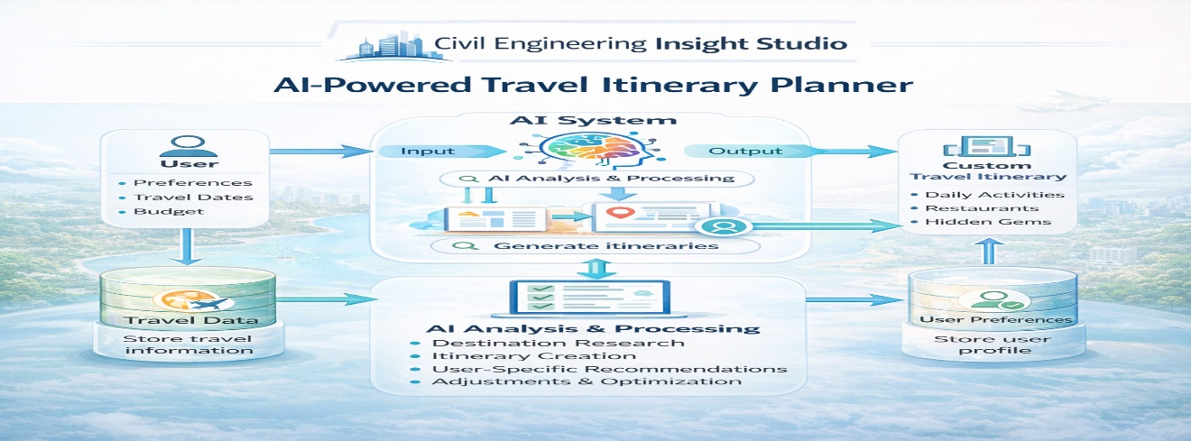
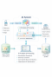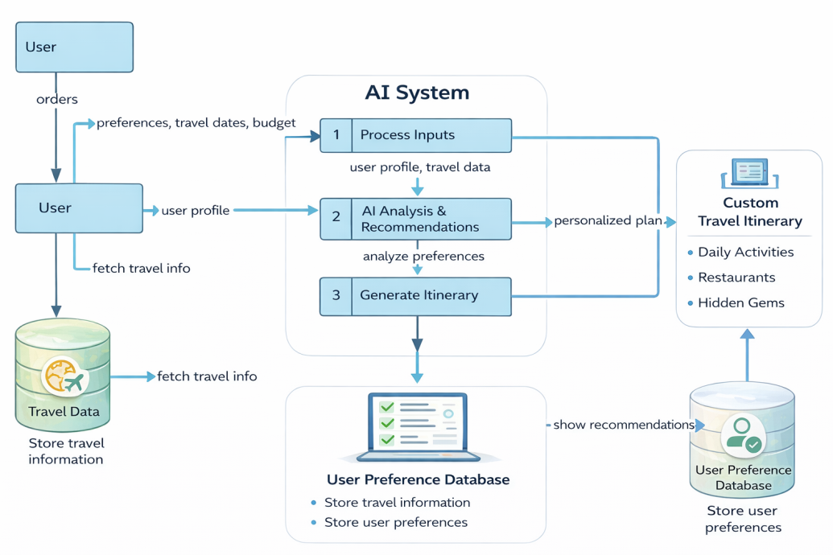
User Stories
Use the below template to list all the user stories for the product.
User Type | Functional Requirement (Epic) | User Story Number | User Story / Task | Acceptance Criteria | Priority | Release
Customer (Mobile User) | Registration | USN-1 | As a user, I can register for the application by entering my email, password, and confirming my password so that I can access AI-generated travel itineraries. | User can successfully register and access the dashboard. | High | Sprint-1
Customer (Mobile User) | Registration | USN-2 | As a user, I will receive a confirmation email after registering so that I can verify my account. | User receives confirmation email and can activate the account. | High | Sprint-1
Customer (Mobile User) | Registration | USN-3 | As a user, I can register using Facebook so that I can quickly access personalized travel planning. | User can register and access the dashboard using Facebook login. | Low | Sprint-2
Customer (Mobile User) | Registration | USN-4 | As a user, I can register using my Gmail account so that I can sign up faster. | User can register and access the dashboard using Gmail login. | Medium | Sprint-1
Customer (Mobile User) | Login | USN-5 | As a user, I can log in using my email and password so that I can access my saved itineraries. | User can log in and access their dashboard. | High | Sprint-1
Customer (Mobile User) | Dashboard | USN-6 | As a user, I can view AI-generated custom itineraries based on my preferences. | User can see personalized itineraries on the dashboard. | High | Sprint-1
Customer (Mobile User) | Itinerary Creation | USN-7 | As a user, I can enter travel preferences such as destination, budget, and dates so that AI can generate a custom itinerary. | AI generates itinerary based on entered preferences. | High | Sprint-1
Customer (Mobile User) | Itinerary Management | USN-8 | As a user, I can save and view my itineraries so that I can access them later. | User can save and retrieve itineraries. | High | Sprint-2
Customer (Web User) | Access Platform | USN-9 | As a web user, I can log in and access AI-generated itineraries through the web platform. | User can log in and view itineraries via web interface. | Medium | Sprint-2
Customer Care Executive | Support Management | USN-10 | As a customer care executive, I can view user accounts and assist with itinerary issues. | Executive can access user account information and provide support. | Medium | Sprint-3
Administrator | System Management | USN-11 | As an administrator, I can manage users and system data so that the platform runs efficiently. | Admin can view, update, and manage system data. | High | Sprint-3

